Keycloak with postgres

IOp - Hub

Exported on May 30, 2018

Table of Contents

1 Overview 3

2 Create 'keycloak' database on postgres 4

3 Create user 'keycloak' with password 'keycloak' 5

4 Change configuration on Keycloak 6

5 Start Keycloak 7

6 Open Keycloak Admin console 8

# Overview

Originally Keycloak uses H2 database. Due to security reasons we should change this setup for Keycloak to work with postgres database.

# Create 'keycloak' database on postgres

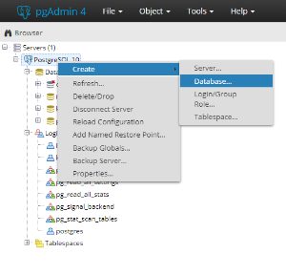 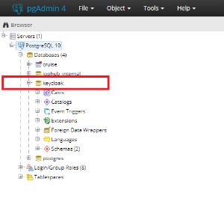

# Create user 'keycloak' with password 'keycloak'

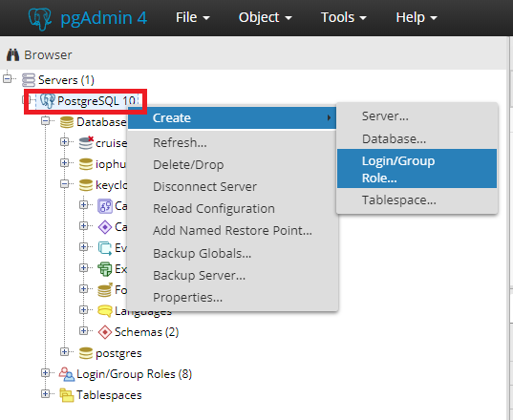 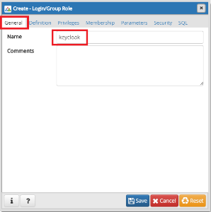 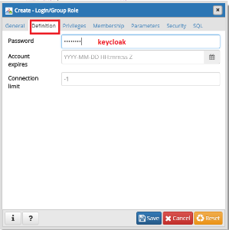 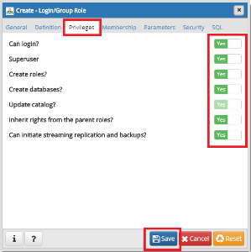

To check users run this query:

Code Block 1 Check users

|  |
| --- |
| SELECT u.usename AS "User name", u.usesysid AS "User ID", CASE WHEN u.usesuper AND u.usecreatedb THEN CAST('superuser, create database' AS pg_catalog.text) WHEN u.usesuper THEN CAST('superuser' AS pg_catalog.text) WHEN u.usecreatedb THEN CAST('create database' AS pg_catalog.text) ELSE CAST('' AS pg_catalog.text) END AS "Attributes" FROM pg_catalog.pg_user u ORDER BY 1; |

# Change configuration on Keycloak

* Open **C:\keycloak-2.5.1.Final\standalone\configuration\standalone.xml** file
* Comment existing datasource code (H2) and replace with new one (postgres)

Code Block 2 datasource H2

|  |
| --- |
| <!-- <datasource jndi-name="java:jboss/datasources/KeycloakDS" pool-name="KeycloakDS" enabled="true" use-java-context="true">  <connection-url>jdbc:h2:${jboss.server.data.dir}/keycloak;AUTO_SERVER=TRUE</connection-url>  <driver>h2</driver>  <security>  <user-name>sa</user-name>  <password>sa</password>  </security> </datasource> --> |

Code Block 3 datasource postgres

|  |
| --- |
| <datasource jndi-name="java:jboss/datasources/KeycloakDS" pool-name="KeycloakDS" enabled="true" use-java-context="true">  <connection-url>jdbc:postgresql://localhost/keycloak</connection-url>  <driver>postgresql</driver>  <pool>  <min-pool-size>5</min-pool-size>  <max-pool-size>20</max-pool-size>  </pool>  <security>  <user-name>keycloak</user-name>  <password>keycloak</password>  </security> </datasource> |

* add driver code for postgres (no need to remove old H2 driver)

Code Block 4 driver postgres

|  |
| --- |
| <driver name="postgresql" module="org.postgresql">  <xa-datasource-class>org.postgresql.xa.PGXADataSource</xa-datasource-class> </driver> |

* Create folders structure **modules\system\layers\keycloak\org\postgresql\main** in **C:\keycloak-2.5.1.Final\**
* Paste these files into main folder ([module.xml](https://confluence.kapschtraffic.com/download/attachments/63963964/module.xml?version=1&modificationDate=1527590861497&api=v2) and [postgresql-42.2.2.jar](https://confluence.kapschtraffic.com/download/attachments/63963964/postgresql-42.2.2.jar?version=1&modificationDate=1527590898271&api=v2))

# Start Keycloak

* Run powershell in **C:\keycloak-2.5.1.Final\standalone\bin**
* Execute command .\standalone.bat and check logs on the screen. There should be a lot of INFO messages, but if you see ERROR message stop the console and check the error resolution.

This action creates database schema on postgres and initializes basic data. **When you run Keycloak for the first time 1 error will be displayed** "ERROR [org.jboss.resteasy.resteasy_jaxrs.i18n] (default task-35) RESTEASY002010: Failed to execute: javax.ws.rs.NotFoundException: **Realm does not exist**". Disregard it for now!!!

# Open Keycloak Admin console

* Run Keycloak Admin console in Chrome <http://localhost:8080>

When you run it for the first time it offers you to create default user, so create one (e.g. admin/admin)

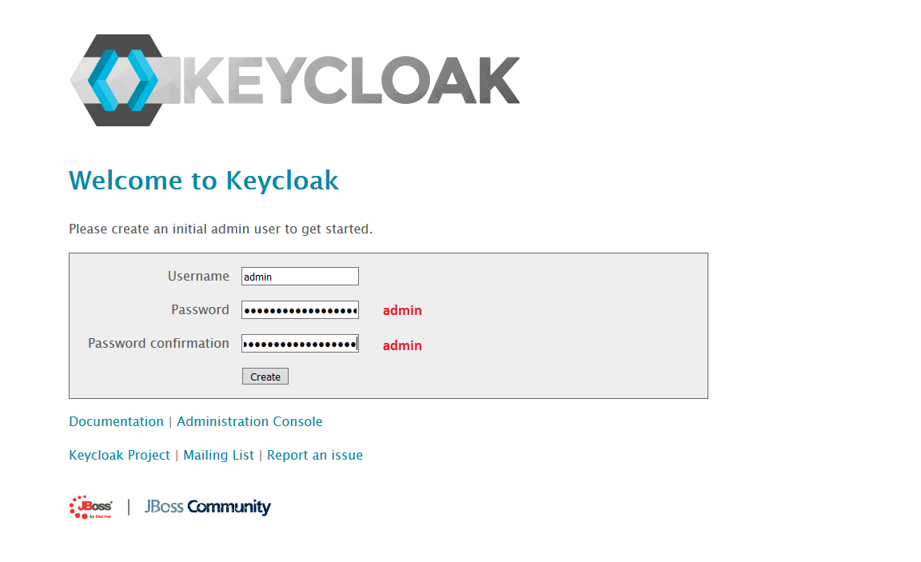

* Open Administration Console

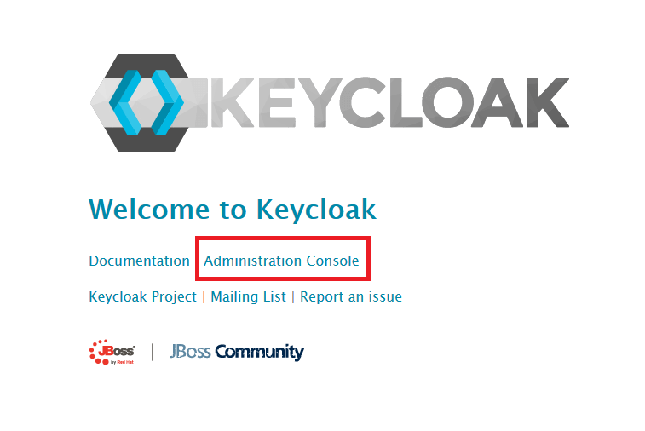

* login

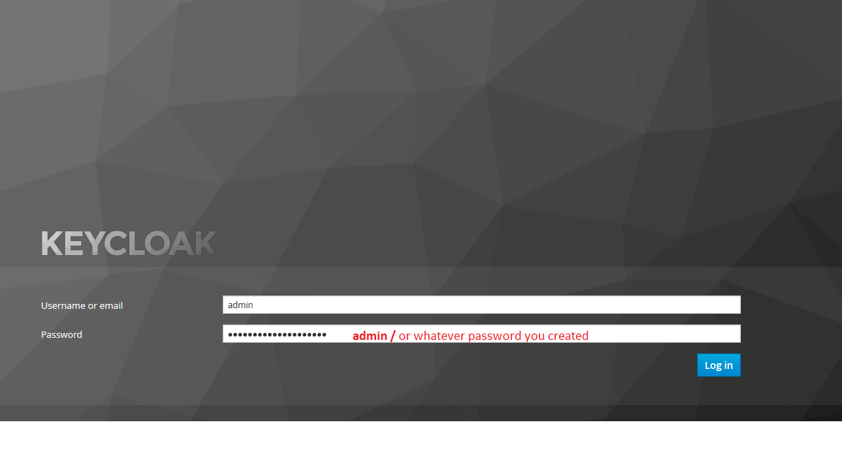

* add realm iophub (download this file [keycloak-realm_iophub.json)](https://confluence.kapschtraffic.com/download/attachments/63963964/keycloak-realm_iophub.json?version=1&modificationDate=1527588743273&api=v2)

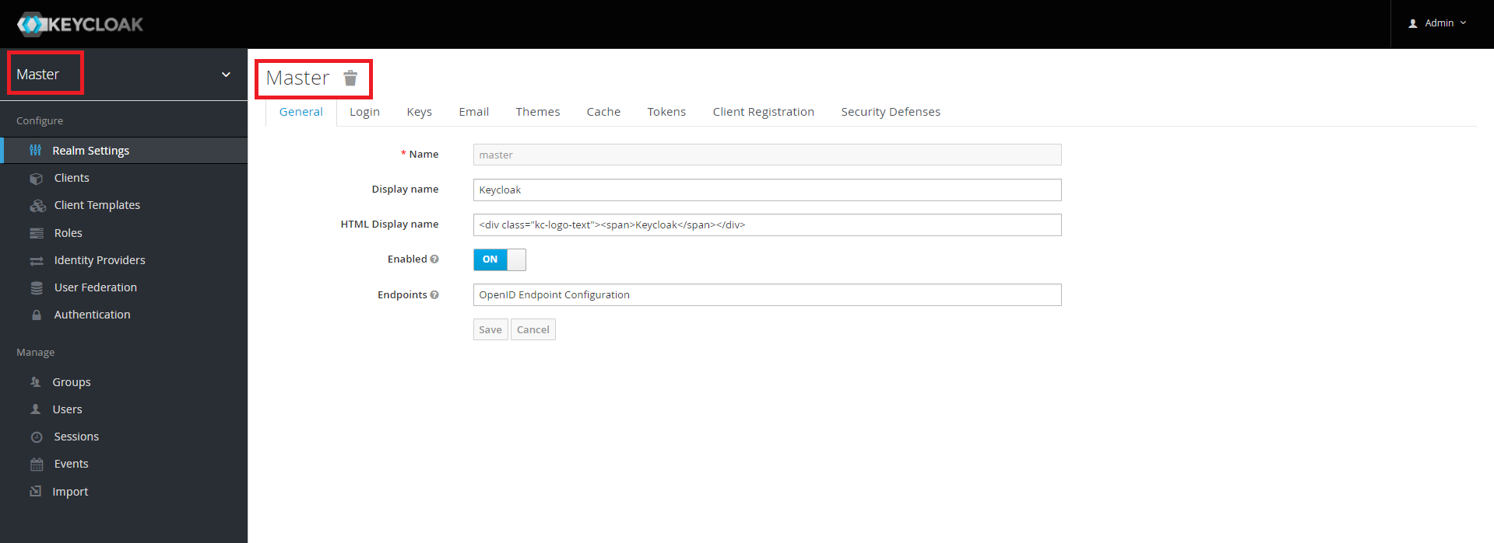

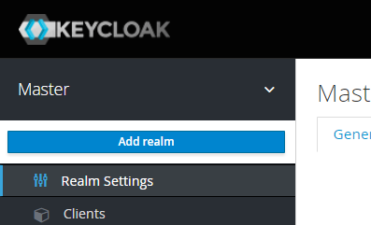 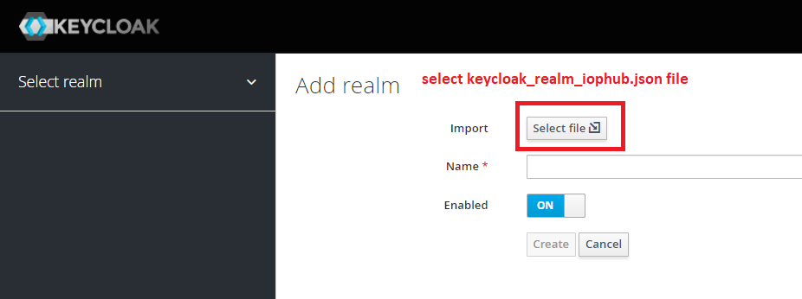

* create users in IOPHUB realm with proper roles (operator, administrator or super_user) as described in Keycloak installation guide

